## 

| **International School**  **CAPSTONE PROJECT 1**  **CMU-SE-450 / CMU-IS-450 / CMU-CS-450**  INTERFACE DESIGN DOCUMENT  Version 1.2  Date: 15 - Nov - 2020  **SMART DASHBOARD** APPLICATION  Submitted by  Vo Van Hoa  Pham Van Tin  Ky Huu Dong  Tran Thanh Kieu  **Approved by**  **Capstone Project 1 - Mentor:**  Name Signature Date  Binh, Thanh Nguyen __________________14 - Dec- 2020    Name Signature Date  Huy, Truong Dinh _________________________________________________________________ |
| --- |

| **PROJECT INFORMATION** | | | |
| --- | --- | --- | --- |
| **Project Acronym** | SDA | | |
| **Project Title** | Smart Dashboard Application | | |
| **Project Web URL** | <https://sda-research.ml/> | | |
| **Start Date** | 12 - Aug - 2020 | | |
| **End Date:** | 15 - Dec - 2020 | | |
| **Lead Institution** | International School, Duy Tan University | | |
| **Project Mentor** | PhD Binh, Nguyen Thanh; MSc Huy, Truong Dinh | | |
| **Scrum Master** | Hoa, Vo | hoavo.dng@gmail.com | 0935.193.182 |
| **Team Members** | Tin, Pham Van | tinphamvan123@gmail.com | 0932.535.175 |
| Dong, Ky Huu | kyhuudong@gmail.com | 0898.246.980 |
| Kieu, Tran Thanh | thanhkieutran391@gmail.com | 0358.583.251 |

| **DOCUMENT INFORMATION** | | | |
| --- | --- | --- | --- |
| **Document Title** | Interface Design Document | | |
| **Author(s)** | Team C1SE.06 | | |
| **Role** | [SDA] Interface_Design_v1.2 | | |
| **Date** | 15 - Nov - 2020 | File name | [SDA] Interface_Design_v1.2 |
| **URL** | <https://github.com/sdateamdtu2020/sda-documents> | | |
| **Access** | Project and CMU Program | | |

## 

## REVISION HISTORY

| **Version** | **Person(s)** | **Date** | **Description** | **Approval** |
| --- | --- | --- | --- | --- |
| Draft | Tin, Pham | 12 - Aug - 2020 | Initiate document | x |
| 1.0 | Tin, Pham | 15 - Nov - 2020 | Finish content of interface design | x |
| 1.1 | Tin, Pham | 20 - Nov - 2020 | Update UI | x |
| 1.2 | Tin | 13 - Dec - 2020 | Update UI when merge | x |
|  |  |  |  |  |
|  |  |  |  |  |
|  |  |  |  |  |
|  |  |  |  |  |
|  |  |  |  |  |
|  |  |  |  |  |
|  |  |  |  |  |
|  |  |  |  |  |
|  |  |  |  |  |

## 

# 

# TABLE OF CONTENTS

PROJECT INFORMATION 1

DOCUMENT INFORMATION 1

REVISION HISTORY 2

**TABLE OF CONTENTS 3**

1. **INTRODUCTION 5**
   1. PURPOSE 5
   2. INTENDED AUDIENCE 5
   3. DOCUMENT OVERVIEW 5
2. **DETAILED INTERFACE DESIGN 6**
   1. HOMEPAGE 6
   2. NAVBAR 7
      1. IN HOMEPAGE 7
      2. IN DASHBOARD PAGE 8
   3. FOOTER 8
   4. DASHBOARD PAGE 9
   5. TOOLBAR 10
   6. CONNECTOR 11
   7. INDUSTRY PRODUCTION 12
      1. IN TREE VIEW 12
      2. IN VISUALIZATION 15
   8. Temperature 20
      1. IN TREE VIEW 20
      2. IN VISUALIZATION 23
   9. Humidity 28
      1. IN TREE VIEW 28
      2. IN VISUALIZATION 32
   10. Rainfall 37
       1. IN TREE VIEW 37
       2. IN VISUALIZATION 41
   11. Population 46
       1. IN TREE VIEW 46
       2. IN VISUALIZATION 49

# INTRODUCTION

## PURPOSE OF DOCUMENT

This IDD of the SDA system has the following purpose:

* Document the design of user interface of functions of SDA
* Be the primary document driving the implementation of the user interfaces.
* Introduce interface design for the reader. Including the background, content information display, command buttons.

## INTENDED AUDIENCES

This IDD is intended for the following audiences:

* Technical reviewers including:
* Scrum Master
* Product owner
* Implementers, including:
  + Developers.
  + Testers.

## DOCUMENT OVERVIEW

This IDD is organized into the following sections:

* This document helps to better understand the interface of the Smart Dashboard Application System, detailed specification components and function of the Application.
* With this document, the development team can understand the structure and composition to create a consistent and complete system.
* Overview of the stages and modules of the software and create a complete interface.

# DETAILED INTERFACE DESIGN

## Homepage

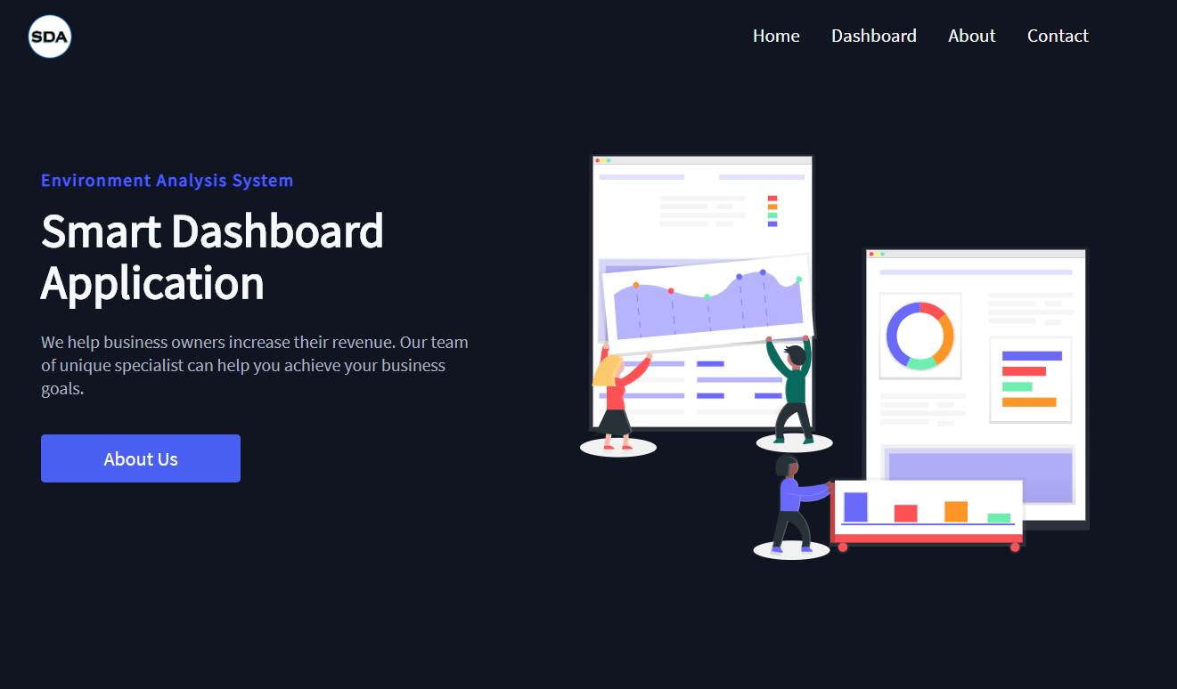

| **Homepage** | | | | |
| --- | --- | --- | --- | --- |
| **No.** | **Field name** | **Type** | **Require** | **Target** |
| 1 | Background |  | Background: #101522 |  |
| 2 | Heading | H1 tag | Font-size: 48px  Font-weight: 600  Color: #f7f8fa | Smart Dashboard Application |
| 3 | Subtitle | P tag | Font-size: 18px  Color: #a9b3c1 | Short introduction about SDA |
| 4 | Button | button | Background: #4b59f7  Padding: 10 20px  Color: #fff  Font-size: 16px; | Redirect to /about page |
| 5 | Thumbnail | image |  | homepage.svg |

## Navbar

### IN HOME PAGE



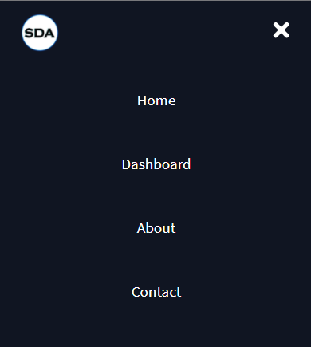

| **Navbar** | | | | |
| --- | --- | --- | --- | --- |
| **No.** | **Field name** | **Type** | **Require** | **Target** |
| 1 | Logo | image |  | logo.png |
| 2 | Menu | List | Height: 90px; Font-size: 19px; Font-family: “Source sans pro”. Responsive: max-width: 960px; | Home, Dashboard, About, Contact |

### IN DASHBOARD PAGE



| **Navbar** | | | | |
| --- | --- | --- | --- | --- |
| **No.** | **Field name** | **Type** | **Require** | **Target** |
| 1 | Logo | image |  | logo.png |
| 2 | Group Button | button | Width: 100px;  Height: 35px; | New, Save, Help, Example 1, Example 2 |

## Footer





| **Footer** | | | | |
| --- | --- | --- | --- | --- |
| **No.** | **Field name** | **Type** | **Require** | **Target** |
| 1 | Logo | image |  | logo.png |
| 2 | Credits | P tag | Font-size: 19px;  Font-family: “source sans pro”  Responsive: 960px | SDA-Team © 2020 |
| 3 | Github Link | Icon Button | Icon name: “FaGithub” | https://github.com/sdateamdtu2020 |

## Dashboard page

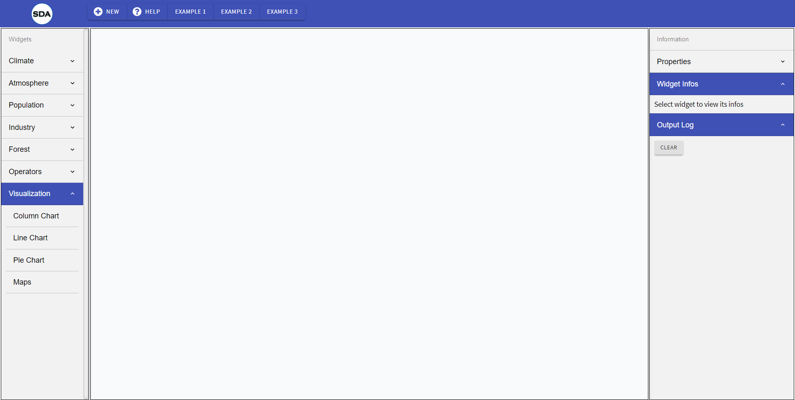

| **Dashboard page** | | | | |
| --- | --- | --- | --- | --- |
| **No.** | **Field name** | **Type** | **Require** | **Target** |
| 1 | Toolbar | div | Width: 185px  Height: full height |  |
| 2 | Info | div | Width: 320px |  |
| 3 | MashupContent | div | Width: 100vw - toolbar - info |  |

## Toolbar

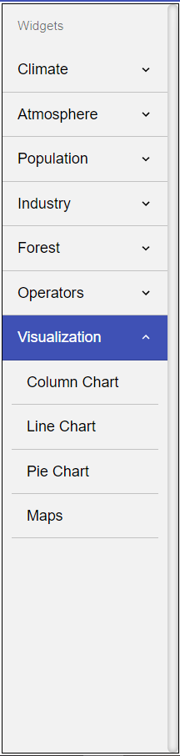

| **Toolbar** | | | | |
| --- | --- | --- | --- | --- |
| **No.** | **Field name** | **Type** | **Require** | **Target** |
| 1 | Widgets | Dropdown menu | Climate: Average Temperature, Average Precipitation, Average Rainfall  Atmosphere: Air Quality Station, Air Quality Filter  Population: Population  Industry: Industry Production  Forest: Forest Cover Area, AfForestation  Operators: Statistics Merge, Simple Merge  Visualization: Column Chart, Line Chart, Pie Chart, Maps  Each dataSet have 3 dimensions: Year, City, Period of City | |
| 2 | Default state is Open |  | Visualization: true | |
| 3 | ListItem |  | Color: rgb(242, 242, 242), hover: #3f51b5 | |

## Connector

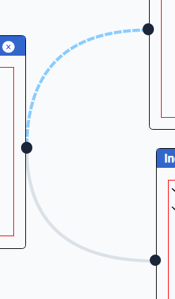

| **Connector** | | | | |
| --- | --- | --- | --- | --- |
| **No.** | **Field name** | **Type** | **Require** | **Target** |
| 1 | Line | SVG | Stroke: #dae1e7; |  |
| 2 | Port | Button | Port In & Port Out |  |

## Industry Production

### IN TREE VIEW

#### Filter By Year

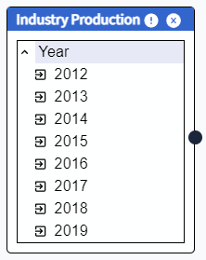

| **Industry Production** | | | | |
| --- | --- | --- | --- | --- |
| **No.** | **Field name** | **Type** | **Require** | **Target** |
| 1 | Icon | image | Icon name: MdExpandLess, MdExpandMore, MdExitToApp |  |
| 2 | Header | P tag | Font-size: 16px  Font-family: “Source sans pro”  Font-weight: bold | Industry Production |
| 3 | Close | button | Icon name: AiFillCloseCircle | When onClick, close the node |
| 4 | Port | button | Port In & Port Out |  |
| 5 | Info | button | Icon name: RiErrorWarningFill | When onClick, display widget info in Info container |
| 6 | Data |  | 2012 to 2019 |  |

#### Filter By City

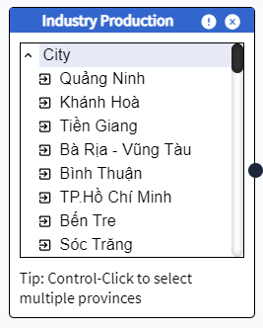

| **Industry Production** | | | | |
| --- | --- | --- | --- | --- |
| **No.** | **Field name** | **Type** | **Require** | **Target** |
| 1 | Icon | image | Icon name: MdExpandLess, MdExpandMore, MdExitToApp |  |
| 2 | Header | P tag | Font-size: 16px  Font-family: “Source sans pro”  Font-weight: bold | Industry Production |
| 3 | Close | button | Icon name: AiFillCloseCircle | When onClick, close the node |
| 4 | Port | button | Port In & Port Out |  |
| 5 | Info | button | Icon name: RiErrorWarningFill | When onClick, display widget info in Info container |
| 6 | Data |  | 64 province in VN |  |

#### Filter By Period of City

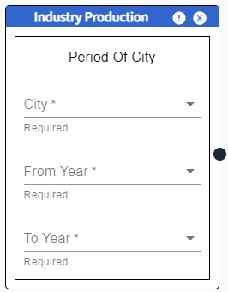

| **Industry Production** | | | | |
| --- | --- | --- | --- | --- |
| **No.** | **Field name** | **Type** | **Require** | **Target** |
| 1 | Icon | image | Icon name: MdExpandLess, MdExpandMore, MdExitToApp |  |
| 2 | Header | P tag | Font-size: 16px  Font-family: “Source sans pro”  Font-weight: bold | Industry Production |
| 3 | Close | button | Icon name: AiFillCloseCircle | When onClick, close the node |
| 4 | Port | button | Port In & Port Out |  |
| 5 | Info | button | Icon name: RiErrorWarningFill | When onClick, display widget info in Info container |
| 6 | Data |  | City: 64 province in VN  FromYear: 2012 to 2019  ToYear: 2012 to 2019  ToYear > FromYear |  |

### IN VISUALIZATION

#### Column

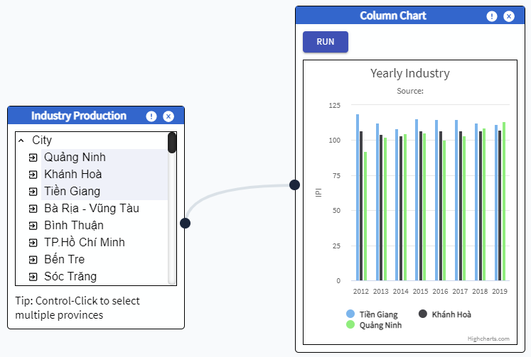

| **Maps** | | | | |
| --- | --- | --- | --- | --- |
| **No.** | **Field name** | **Type** | **Require** | **Target** |
| 1 | Chart | Column | Width: 350px; | Industry of cities from 2012 to 2019 |
| 2 | Port | button | Port in |  |
| 3 | Maps Title |  | Default: “”  Running: “Industry of VN ${year}” | Industry of VN 2012 |

#### Line Chart

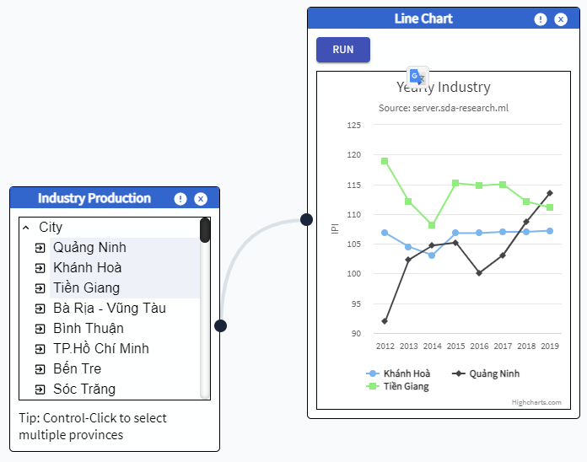

| **Maps** | | | | |
| --- | --- | --- | --- | --- |
| **No.** | **Field name** | **Type** | **Require** | **Target** |
| 1 | Chart | Line | Width: 350px; | Industry of cities from 2012 to 2019 |
| 2 | Port | button | Port in |  |
| 3 | Maps Title |  | Default: “”  Running: “Industry of VN ${year}” | Industry of VN 2012 |

#### Maps

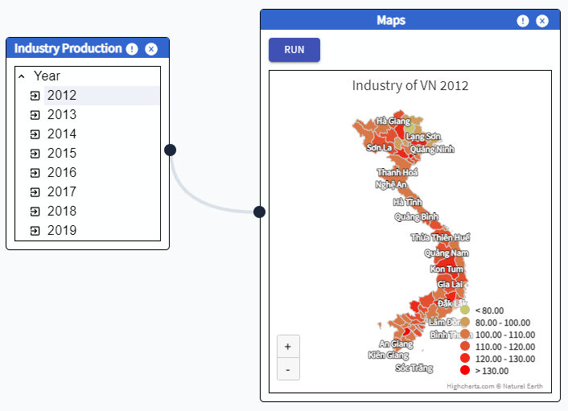

| **Maps** | | | | |
| --- | --- | --- | --- | --- |
| **No.** | **Field name** | **Type** | **Require** | **Target** |
| 1 | Maps | HighChart/Highmaps | Width: 350px;  colorAxis: min: 50, minColor: "#E6E7E8",  maxColor: "#005645", | Industry of VN 2012 to 2019 |
| 2 | Port | button | Port in |  |
| 3 | colorAxis |  | Min: 0  minColor: b"rgb(197, 197, 115)", maxColor: "rgb(247, 2, 2)",  colorRange:   * To 80 * From 80 to 100 * From 100 to 110 * From 110 to 120 * From 120 to 130 * From 130   Hover: color: #EEDD66 |  |
| 4 | Maps Title |  | Default: “”  Running: “Industry of VN ${year}” | Industry of VN 2012 |

#### Viz data Cities in year

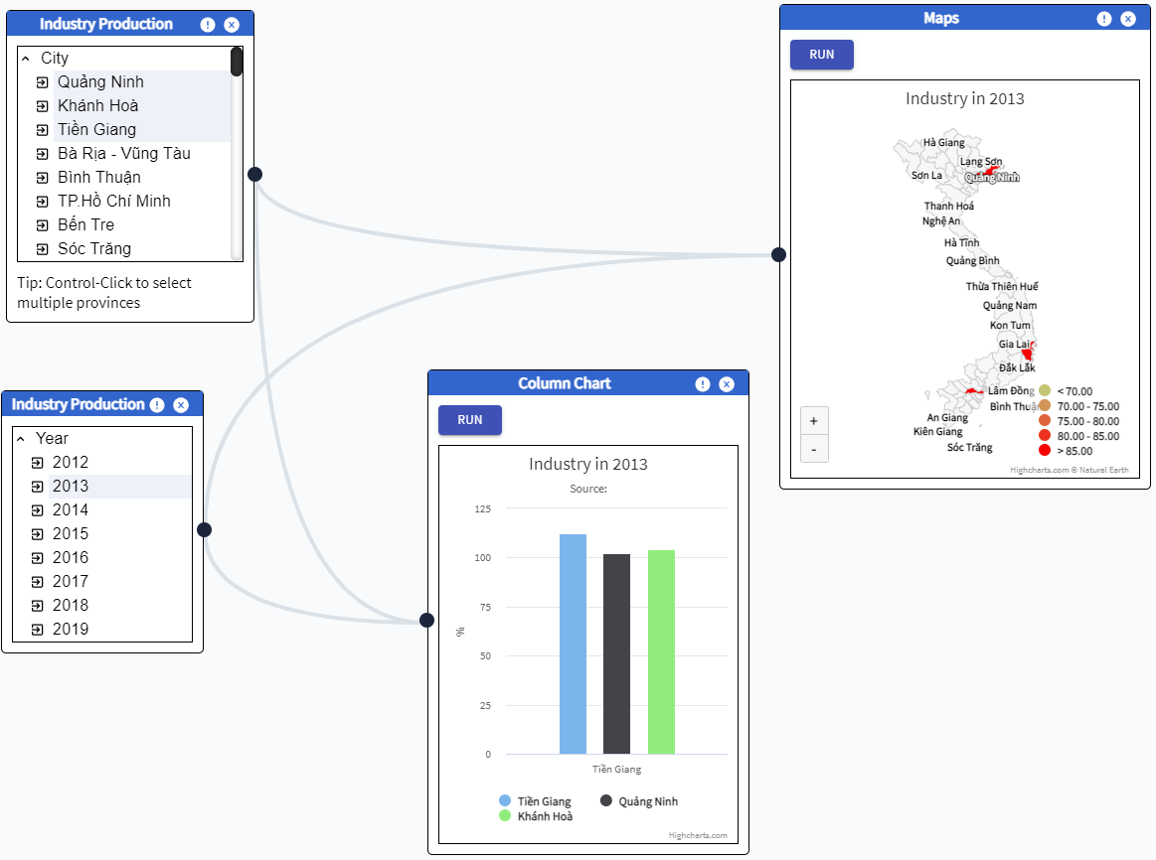

| **Cities In Year** | | | | |
| --- | --- | --- | --- | --- |
| **No.** | **Field name** | **Type** | **Require** | **Target** |
| 1 | Maps | HighChart/Highmaps | Width: 350px;  colorAxis: min: 50, minColor: "#E6E7E8",  maxColor: "#005645", | Industry of cities in year |
| 2 | Chart | Column | Width: 300px; | Industry of cities in year |
| 3 | colorAxis |  | Min: 0  minColor: b"rgb(197, 197, 115)", maxColor: "rgb(247, 2, 2)",  colorRange:   * To 80 * From 80 to 100 * From 100 to 110 * From 110 to 120 * From 120 to 130 * From 130   Hover: color: #EEDD66 |  |
| 4 | Maps Title |  | Default: “”  Running: “Industry in ${year}” | Industry in year |

## TEMPERATURE

### IN TREE VIEW

#### Filter By Year

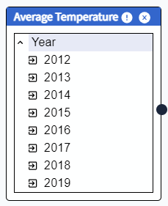

| **TEMPERATURE** | | | | |
| --- | --- | --- | --- | --- |
| **No.** | **Field name** | **Type** | **Require** | **Target** |
| 1 | Icon | image | Icon name: MdExpandLess, MdExpandMore, MdExitToApp |  |
| 2 | Header | P tag | Font-size: 16px  Font-family: “Source sans pro”  Font-weight: bold | Average Temperature |
| 3 | Close | button | Icon name: AiFillCloseCircle | When onClick, close the node |
| 4 | Port | button | Port In & Port Out |  |
| 5 | Info | button | Icon name: RiErrorWarningFill | When onClick, display widget info in Info container |
| 6 | Data |  | 2012 to 2019 |  |

#### Filter By City

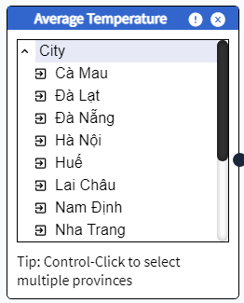

| **TEMPERATURE** | | | | |
| --- | --- | --- | --- | --- |
| **No.** | **Field name** | **Type** | **Require** | **Target** |
| 1 | Icon | image | Icon name: MdExpandLess, MdExpandMore, MdExitToApp |  |
| 2 | Header | P tag | Font-size: 16px  Font-family: “Source sans pro”  Font-weight: bold | Industry Production |
| 3 | Close | button | Icon name: AiFillCloseCircle | When onClick, close the node |
| 4 | Port | button | Port In & Port Out |  |
| 5 | Info | button | Icon name: RiErrorWarningFill | When onClick, display widget info in Info container |
| 6 | Data |  | Cà Mau, Đà Lạt, Đà Nẵng, Hà Nội, Huế, Lai Châu, Nam Định, Nha Trang, Pleiku, Qui Nhơn, Sơn La, Tuyên Quang, Vinh, Vũng Tàu |  |

#### Filter By Period of City

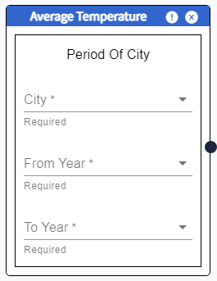

| **TEMPERATURE** | | | | |
| --- | --- | --- | --- | --- |
| **No.** | **Field name** | **Type** | **Require** | **Target** |
| 1 | Icon | image | Icon name: MdExpandLess, MdExpandMore, MdExitToApp |  |
| 2 | Header | P tag | Font-size: 16px  Font-family: “Source sans pro”  Font-weight: bold | Industry Production |
| 3 | Close | button | Icon name: AiFillCloseCircle | When onClick, close the node |
| 4 | Port | button | Port In & Port Out |  |
| 5 | Info | button | Icon name: RiErrorWarningFill | When onClick, display widget info in Info container |
| 6 | Data |  | City: Cà Mau, Đà Lạt, Đà Nẵng, Hà Nội, Huế, Lai Châu, Nam Định, Nha Trang, Pleiku, Qui Nhơn, Sơn La, Tuyên Quang, Vinh, Vũng Tàu  FromYear: 2012 to 2019  ToYear: 2012 to 2019  ToYear > FromYear |  |

### IN VISUALIZATION

#### Column

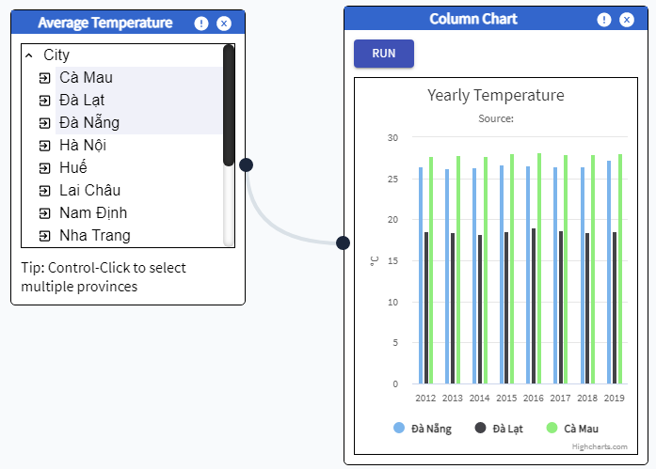

| **Column** | | | | |
| --- | --- | --- | --- | --- |
| **No.** | **Field name** | **Type** | **Require** | **Target** |
| 1 | Chart | Column | Width: 350px; | Industry of cities from 2012 to 2019 |
| 2 | Port | button | Port in |  |
| 3 | Maps Title |  | Default: “”  Running: “Industry of VN ${year}” | Industry of VN 2012 |

#### Line Chart

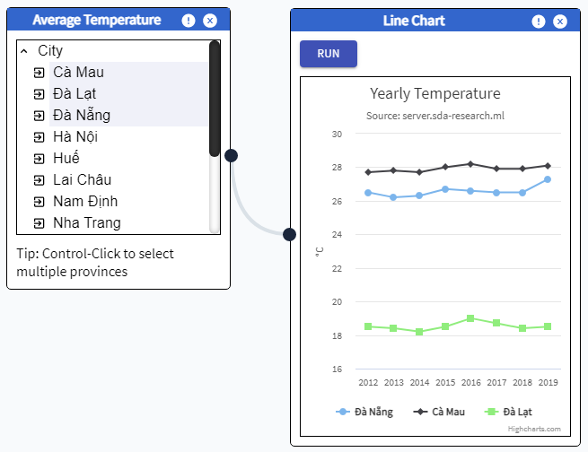

| **Line** | | | | |
| --- | --- | --- | --- | --- |
| **No.** | **Field name** | **Type** | **Require** | **Target** |
| 1 | Chart | Line | Width: 350px; | Industry of cities from 2012 to 2019 |
| 2 | Port | button | Port in |  |
| 3 | Maps Title |  | Default: “”  Running: “Industry of VN ${year}” | Industry of VN 2012 |

#### Maps

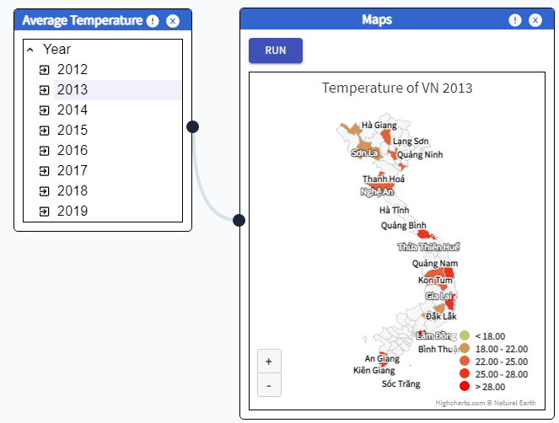

| **Maps** | | | | |
| --- | --- | --- | --- | --- |
| **No.** | **Field name** | **Type** | **Require** | **Target** |
| 1 | Maps | HighChart/Highmaps | Width: 350px;  colorAxis: min: 50, minColor: "#E6E7E8",  maxColor: "#005645", | Industry of VN 2012 to 2019 |
| 2 | Port | button | Port in |  |
| 3 | colorAxis |  | Min: 0  minColor: b"rgb(197, 197, 115)", maxColor: "rgb(247, 2, 2)",  colorRange:   * To 18 * From 18 to 22 * From 22 to 25 * From 25 to 28 * From 28   Hover: color: #EEDD66 |  |
| 4 | Maps Title |  | Default: “”  Running: “Temperature of VN ${year}” | Temperature of VN 2012 |

#### Viz data Cities in year

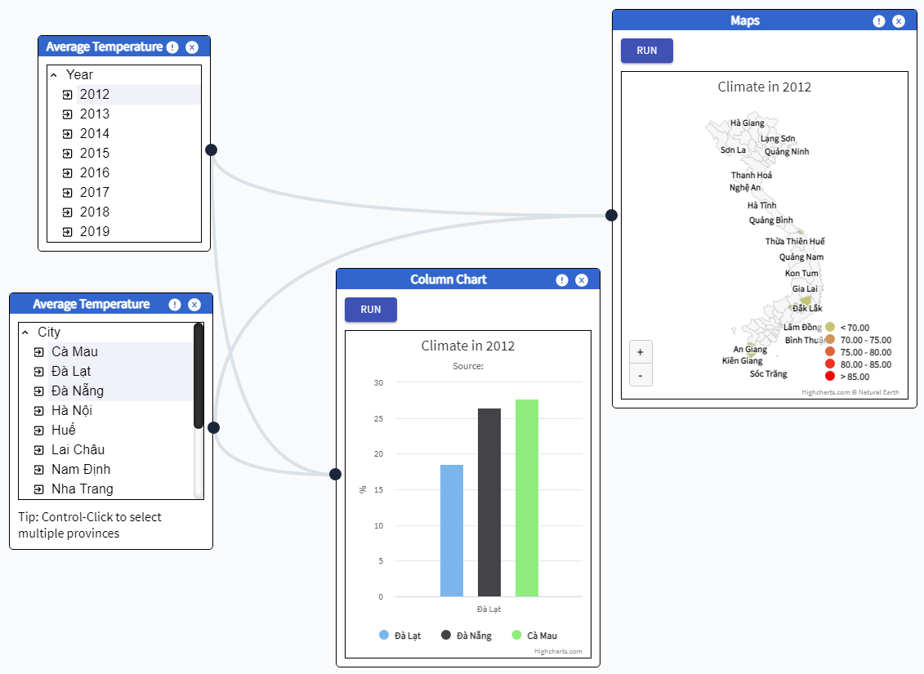

| **Cities In Year** | | | | |
| --- | --- | --- | --- | --- |
| **No.** | **Field name** | **Type** | **Require** | **Target** |
| 1 | Maps | HighChart/Highmaps | Width: 350px;  colorAxis: min: 50, minColor: "#E6E7E8",  maxColor: "#005645", | Temperature of cities in year |
| 2 | Chart | Column | Width: 300px; | Temperature of cities in year |
| 3 | colorAxis |  | Min: 0  minColor: b"rgb(197, 197, 115)", maxColor: "rgb(247, 2, 2)",  colorRange:   * To 80 * From 80 to 100 * From 100 to 110 * From 110 to 120 * From 120 to 130 * From 130   Hover: color: #EEDD66 |  |
| 4 | Maps Title |  | Default: “”  Running: “Temperature in ${year}” | Temperature in year |

## Humidity

### IN TREE VIEW

#### Filter By Year

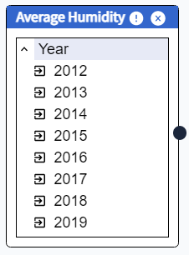

| **Humidity** | | | | |
| --- | --- | --- | --- | --- |
| **No.** | **Field name** | **Type** | **Require** | **Target** |
| 1 | Icon | image | Icon name: MdExpandLess, MdExpandMore, MdExitToApp |  |
| 2 | Header | P tag | Font-size: 16px  Font-family: “Source sans pro”  Font-weight: bold | Average Humidity |
| 3 | Close | button | Icon name: AiFillCloseCircle | When onClick, close the node |
| 4 | Port | button | Port In & Port Out |  |
| 5 | Info | button | Icon name: RiErrorWarningFill | When onClick, display widget info in Info container |
| 6 | Data |  | 2012 to 2019 |  |

#### Filter By City

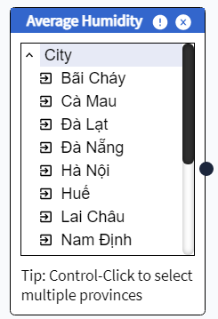

| **Humidity** | | | | |
| --- | --- | --- | --- | --- |
| **No.** | **Field name** | **Type** | **Require** | **Target** |
| 1 | Icon | image | Icon name: MdExpandLess, MdExpandMore, MdExitToApp |  |
| 2 | Header | P tag | Font-size: 16px  Font-family: “Source sans pro”  Font-weight: bold | Industry Production |
| 3 | Close | button | Icon name: AiFillCloseCircle | When onClick, close the node |
| 4 | Port | button | Port In & Port Out |  |
| 5 | Info | button | Icon name: RiErrorWarningFill | When onClick, display widget info in Info container |
| 6 | Data |  | Cà Mau, Đà Lạt, Đà Nẵng, Hà Nội, Huế, Lai Châu, Nam Định, Nha Trang, Pleiku, Qui Nhơn, Sơn La, Tuyên Quang, Vinh, Vũng Tàu |  |

#### Filter By Period of City

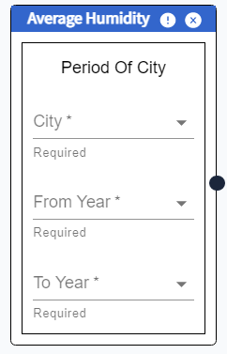

| **Humidity** | | | | |
| --- | --- | --- | --- | --- |
| **No.** | **Field name** | **Type** | **Require** | **Target** |
| 1 | Icon | image | Icon name: MdExpandLess, MdExpandMore, MdExitToApp |  |
| 2 | Header | P tag | Font-size: 16px  Font-family: “Source sans pro”  Font-weight: bold | Industry Production |
| 3 | Close | button | Icon name: AiFillCloseCircle | When onClick, close the node |
| 4 | Port | button | Port In & Port Out |  |
| 5 | Info | button | Icon name: RiErrorWarningFill | When onClick, display widget info in Info container |
| 6 | Data |  | City: Cà Mau, Đà Lạt, Đà Nẵng, Hà Nội, Huế, Lai Châu, Nam Định, Nha Trang, Pleiku, Qui Nhơn, Sơn La, Tuyên Quang, Vinh, Vũng Tàu  FromYear: 2012 to 2019  ToYear: 2012 to 2019  ToYear > FromYear |  |

### IN VISUALIZATION

#### Column

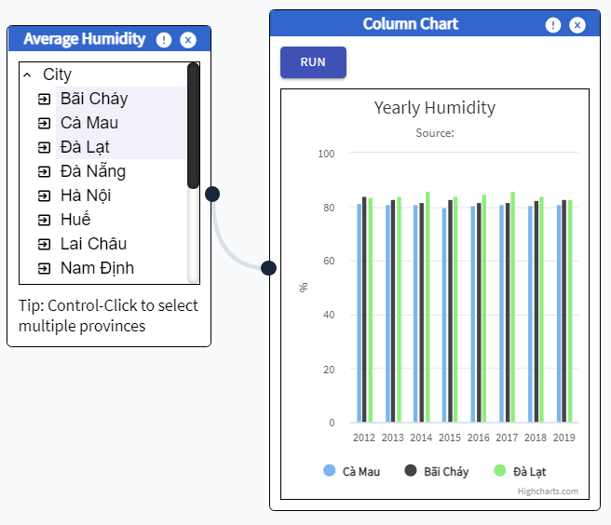

| **Column** | | | | |
| --- | --- | --- | --- | --- |
| **No.** | **Field name** | **Type** | **Require** | **Target** |
| 1 | Chart | Column | Width: 350px; | Industry of cities from 2012 to 2019 |
| 2 | Port | button | Port in |  |
| 3 | Maps Title |  | Default: “”  Running: “Industry of VN ${year}” | Industry of VN 2012 |

#### Line Chart

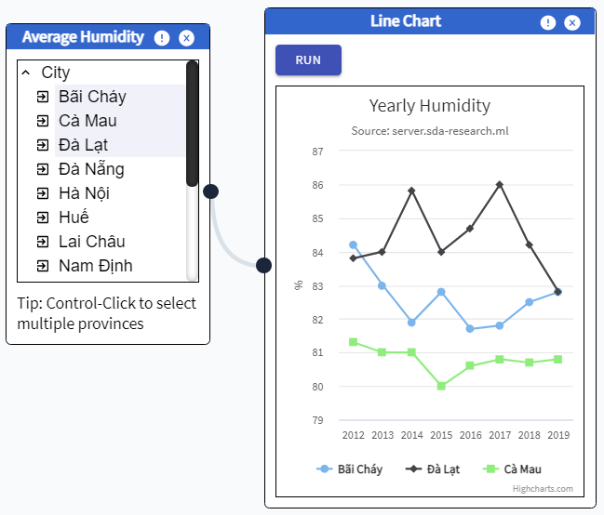

| **Line** | | | | |
| --- | --- | --- | --- | --- |
| **No.** | **Field name** | **Type** | **Require** | **Target** |
| 1 | Chart | Line | Width: 350px; | Humidity of cities from 2012 to 2019 |
| 2 | Port | button | Port in |  |
| 3 | Maps Title |  | Default: “”  Running: “Industry of VN ${year}” | Industry of VN 2012 |

#### Maps

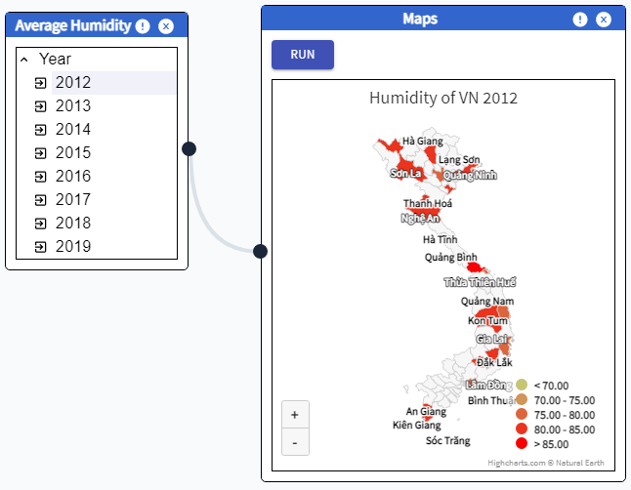

| **Maps** | | | | |
| --- | --- | --- | --- | --- |
| **No.** | **Field name** | **Type** | **Require** | **Target** |
| 1 | Maps | HighChart/Highmaps | Width: 350px;  colorAxis: min: 50, minColor: "#E6E7E8",  maxColor: "#005645", | Industry of VN 2012 to 2019 |
| 2 | Port | button | Port in |  |
| 3 | colorAxis |  | Min: 0  minColor: b"rgb(197, 197, 115)", maxColor: "rgb(247, 2, 2)",  colorRange:   * To 18 * From 18 to 22 * From 22 to 25 * From 25 to 28 * From 28   Hover: color: #EEDD66 |  |
| 4 | Maps Title |  | Default: “”  Running: “Humidity of VN ${year}” | Humidity of VN 2012 |

#### Viz data Cities in year

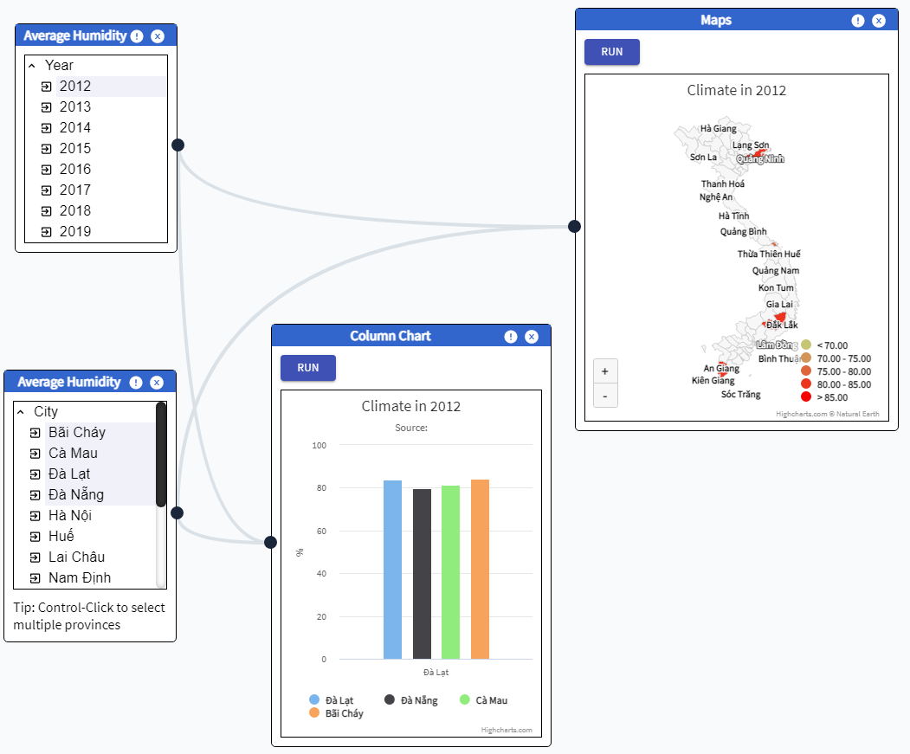

| **Cities In Year** | | | | |
| --- | --- | --- | --- | --- |
| **No.** | **Field name** | **Type** | **Require** | **Target** |
| 1 | Maps | HighChart/Highmaps | Width: 350px;  colorAxis: min: 50, minColor: "#E6E7E8",  maxColor: "#005645", | Humidity of cities in year |
| 2 | Chart | Column | Width: 300px; | Humidity of cities in year |
| 3 | colorAxis |  | Min: 0  minColor: b"rgb(197, 197, 115)", maxColor: "rgb(247, 2, 2)",  colorRange:   * To 80 * From 80 to 100 * From 100 to 110 * From 110 to 120 * From 120 to 130 * From 130   Hover: color: #EEDD66 |  |
| 4 | Maps Title |  | Default: “”  Running: “Humidity in ${year}” | Humidity in year |

## Rainfall

### IN TREE VIEW

#### Filter By Year

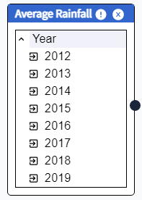

| **Rainfall** | | | | |
| --- | --- | --- | --- | --- |
| **No.** | **Field name** | **Type** | **Require** | **Target** |
| 1 | Icon | image | Icon name: MdExpandLess, MdExpandMore, MdExitToApp |  |
| 2 | Header | P tag | Font-size: 16px  Font-family: “Source sans pro”  Font-weight: bold | Average Rainfall |
| 3 | Close | button | Icon name: AiFillCloseCircle | When onClick, close the node |
| 4 | Port | button | Port In & Port Out |  |
| 5 | Info | button | Icon name: RiErrorWarningFill | When onClick, display widget info in Info container |
| 6 | Data |  | 2012 to 2019 |  |

#### Filter By City

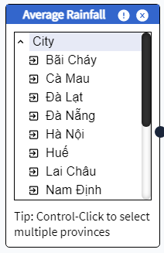

| **Rainfall** | | | | |
| --- | --- | --- | --- | --- |
| **No.** | **Field name** | **Type** | **Require** | **Target** |
| 1 | Icon | image | Icon name: MdExpandLess, MdExpandMore, MdExitToApp |  |
| 2 | Header | P tag | Font-size: 16px  Font-family: “Source sans pro”  Font-weight: bold | Industry Production |
| 3 | Close | button | Icon name: AiFillCloseCircle | When onClick, close the node |
| 4 | Port | button | Port In & Port Out |  |
| 5 | Info | button | Icon name: RiErrorWarningFill | When onClick, display widget info in Info container |
| 6 | Data |  | Cà Mau, Đà Lạt, Đà Nẵng, Hà Nội, Huế, Lai Châu, Nam Định, Nha Trang, Pleiku, Qui Nhơn, Sơn La, Tuyên Quang, Vinh, Vũng Tàu |  |

#### Filter By Period of City

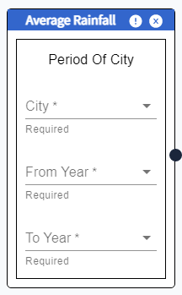

| **Rainfall** | | | | |
| --- | --- | --- | --- | --- |
| **No.** | **Field name** | **Type** | **Require** | **Target** |
| 1 | Icon | image | Icon name: MdExpandLess, MdExpandMore, MdExitToApp |  |
| 2 | Header | P tag | Font-size: 16px  Font-family: “Source sans pro”  Font-weight: bold | Industry Production |
| 3 | Close | button | Icon name: AiFillCloseCircle | When onClick, close the node |
| 4 | Port | button | Port In & Port Out |  |
| 5 | Info | button | Icon name: RiErrorWarningFill | When onClick, display widget info in Info container |
| 6 | Data |  | City: Cà Mau, Đà Lạt, Đà Nẵng, Hà Nội, Huế, Lai Châu, Nam Định, Nha Trang, Pleiku, Qui Nhơn, Sơn La, Tuyên Quang, Vinh, Vũng Tàu  FromYear: 2012 to 2019  ToYear: 2012 to 2019  ToYear > FromYear |  |

### IN VISUALIZATION

#### Column

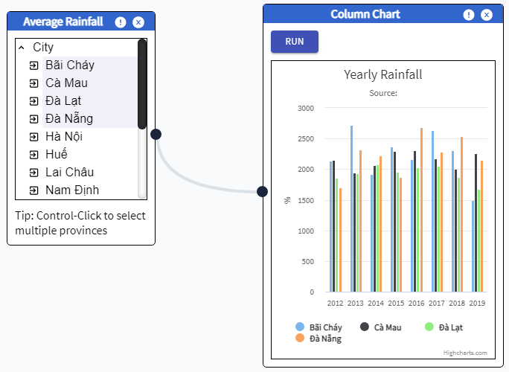

| **Column** | | | | |
| --- | --- | --- | --- | --- |
| **No.** | **Field name** | **Type** | **Require** | **Target** |
| 1 | Chart | Column | Width: 350px; | Industry of cities from 2012 to 2019 |
| 2 | Port | button | Port in |  |
| 3 | Maps Title |  | Default: “”  Running: “Industry of VN ${year}” | Industry of VN 2012 |

#### Line Chart

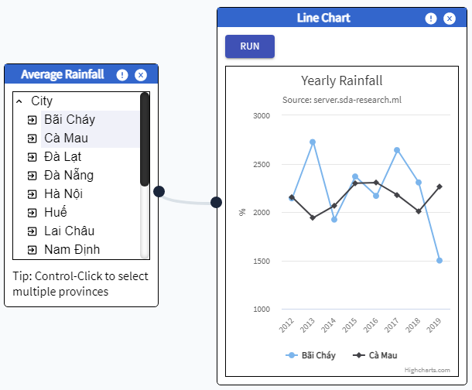

| **Line** | | | | |
| --- | --- | --- | --- | --- |
| **No.** | **Field name** | **Type** | **Require** | **Target** |
| 1 | Chart | Line | Width: 350px; | Rainfall of cities from 2012 to 2019 |
| 2 | Port | button | Port in |  |
| 3 | Maps Title |  | Default: “”  Running: “Industry of VN ${year}” | Industry of VN 2012 |

#### Maps

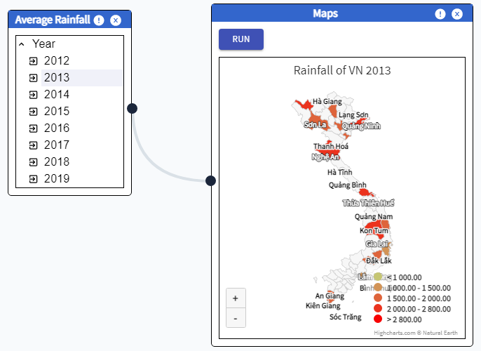

| **Maps** | | | | |
| --- | --- | --- | --- | --- |
| **No.** | **Field name** | **Type** | **Require** | **Target** |
| 1 | Maps | HighChart/Highmaps | Width: 350px;  colorAxis: min: 50, minColor: "#E6E7E8",  maxColor: "#005645", | Industry of VN 2012 to 2019 |
| 2 | Port | button | Port in |  |
| 3 | colorAxis |  | Min: 0  minColor: b"rgb(197, 197, 115)", maxColor: "rgb(247, 2, 2)",  colorRange:   * To 18 * From 18 to 22 * From 22 to 25 * From 25 to 28 * From 28   Hover: color: #EEDD66 |  |
| 4 | Maps Title |  | Default: “”  Running: “Rainfall of VN ${year}” | Rainfall of VN 2012 |

#### Viz data Cities in year

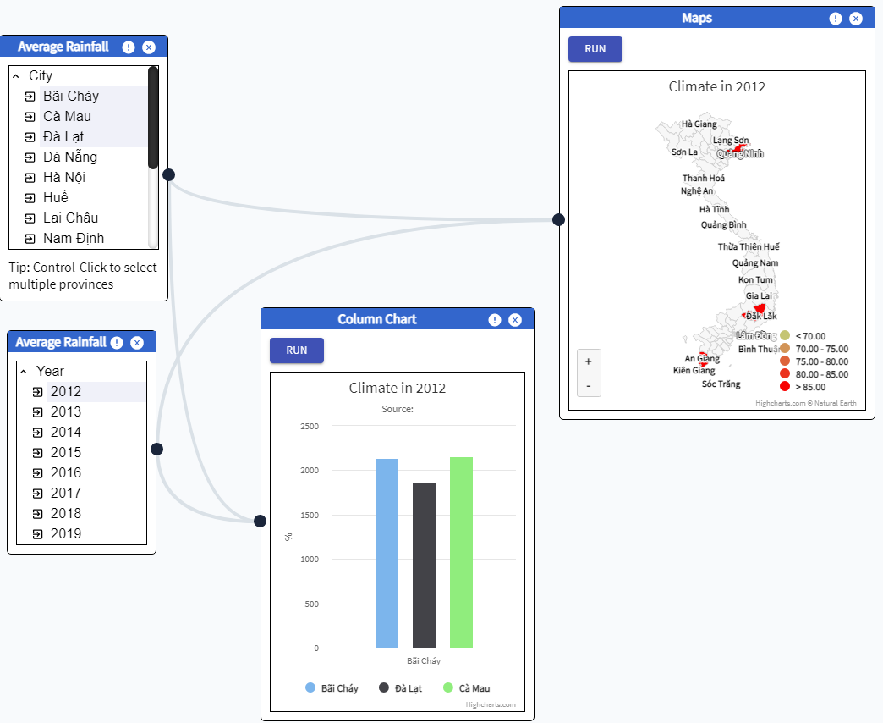

| **Cities In Year** | | | | |
| --- | --- | --- | --- | --- |
| **No.** | **Field name** | **Type** | **Require** | **Target** |
| 1 | Maps | HighChart/Highmaps | Width: 350px;  colorAxis: min: 50, minColor: "#E6E7E8",  maxColor: "#005645", | Rainfall of cities in year |
| 2 | Chart | Column | Width: 300px; | Rainfall of cities in year |
| 3 | colorAxis |  | Min: 0  minColor: b"rgb(197, 197, 115)", maxColor: "rgb(247, 2, 2)",  colorRange:   * To 80 * From 80 to 100 * From 100 to 110 * From 110 to 120 * From 120 to 130 * From 130   Hover: color: #EEDD66 |  |
| 4 | Maps Title |  | Default: “”  Running: “Rainfall in ${year}” | Rainfall in year |

## Population

### IN TREE VIEW

#### Filter By Year

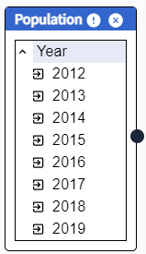

| **Population** | | | | |
| --- | --- | --- | --- | --- |
| **No.** | **Field name** | **Type** | **Require** | **Target** |
| 1 | Icon | image | Icon name: MdExpandLess, MdExpandMore, MdExitToApp |  |
| 2 | Header | P tag | Font-size: 16px  Font-family: “Source sans pro”  Font-weight: bold | Average Population |
| 3 | Close | button | Icon name: AiFillCloseCircle | When onClick, close the node |
| 4 | Port | button | Port In & Port Out |  |
| 5 | Info | button | Icon name: RiErrorWarningFill | When onClick, display widget info in Info container |
| 6 | Data |  | 2012 to 2019 |  |

#### Filter By City

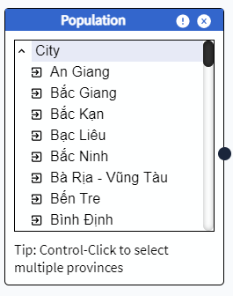

| **Population** | | | | |
| --- | --- | --- | --- | --- |
| **No.** | **Field name** | **Type** | **Require** | **Target** |
| 1 | Icon | image | Icon name: MdExpandLess, MdExpandMore, MdExitToApp |  |
| 2 | Header | P tag | Font-size: 16px  Font-family: “Source sans pro”  Font-weight: bold | Industry Production |
| 3 | Close | button | Icon name: AiFillCloseCircle | When onClick, close the node |
| 4 | Port | button | Port In & Port Out |  |
| 5 | Info | button | Icon name: RiErrorWarningFill | When onClick, display widget info in Info container |
| 6 | Data |  | 64 cities in VN |  |

#### Filter By Period of City

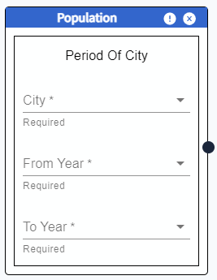

| **Population** | | | | |
| --- | --- | --- | --- | --- |
| **No.** | **Field name** | **Type** | **Require** | **Target** |
| 1 | Icon | image | Icon name: MdExpandLess, MdExpandMore, MdExitToApp |  |
| 2 | Header | P tag | Font-size: 16px  Font-family: “Source sans pro”  Font-weight: bold | Industry Production |
| 3 | Close | button | Icon name: AiFillCloseCircle | When onClick, close the node |
| 4 | Port | button | Port In & Port Out |  |
| 5 | Info | button | Icon name: RiErrorWarningFill | When onClick, display widget info in Info container |
| 6 | Data |  | City: 64 cites in VN  FromYear: 2012 to 2019  ToYear: 2012 to 2019  ToYear > FromYear |  |

### IN VISUALIZATION

#### Column

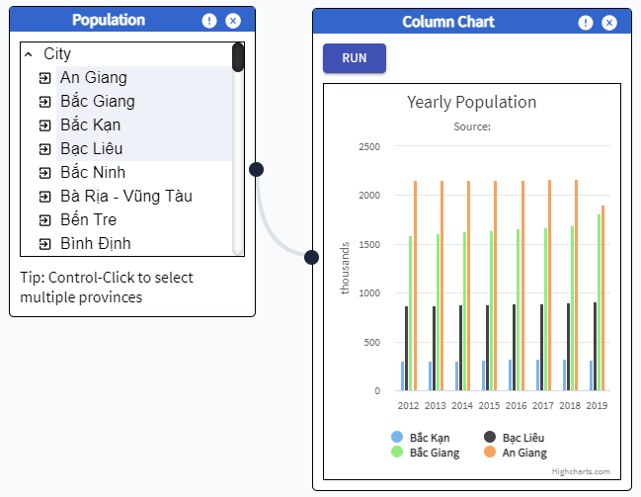

| **Column** | | | | |
| --- | --- | --- | --- | --- |
| **No.** | **Field name** | **Type** | **Require** | **Target** |
| 1 | Chart | Column | Width: 350px; | Industry of cities from 2012 to 2019 |
| 2 | Port | button | Port in |  |
| 3 | Maps Title |  | Default: “”  Running: “Industry of VN ${year}” | Industry of VN 2012 |

#### Line Chart

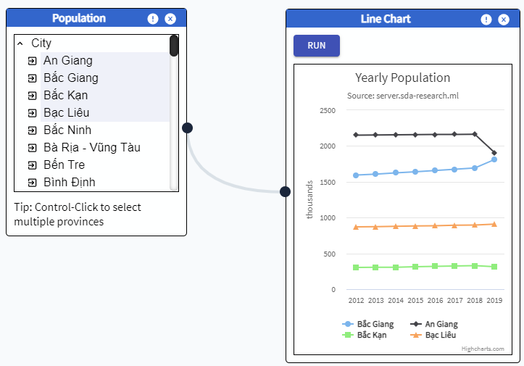

| **Line** | | | | |
| --- | --- | --- | --- | --- |
| **No.** | **Field name** | **Type** | **Require** | **Target** |
| 1 | Chart | Line | Width: 350px; | Population of cities from 2012 to 2019 |
| 2 | Port | button | Port in |  |
| 3 | Maps Title |  | Default: “”  Running: “Industry of VN ${year}” | Industry of VN 2012 |

#### Maps

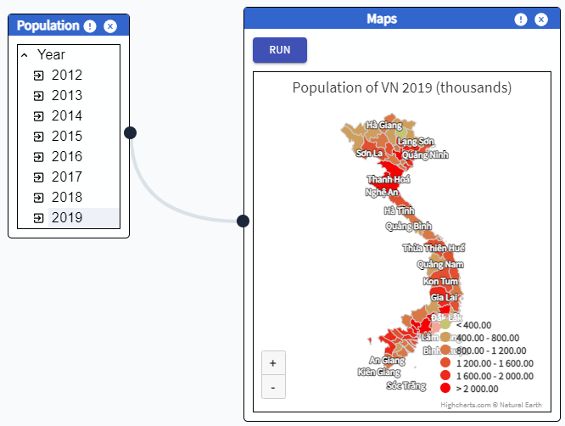

| **Maps** | | | | |
| --- | --- | --- | --- | --- |
| **No.** | **Field name** | **Type** | **Require** | **Target** |
| 1 | Maps | HighChart/Highmaps | Width: 350px;  colorAxis: min: 50, minColor: "#E6E7E8",  maxColor: "#005645", | Industry of VN 2012 to 2019 |
| 2 | Port | button | Port in |  |
| 3 | colorAxis |  | Min: 0  minColor: b"rgb(197, 197, 115)", maxColor: "rgb(247, 2, 2)",  colorRange:   * To 18 * From 18 to 22 * From 22 to 25 * From 25 to 28 * From 28   Hover: color: #EEDD66 |  |
| 4 | Maps Title |  | Default: “”  Running: “Population of VN ${year}” | Population of VN 2012 |

#### Viz data Cities in year

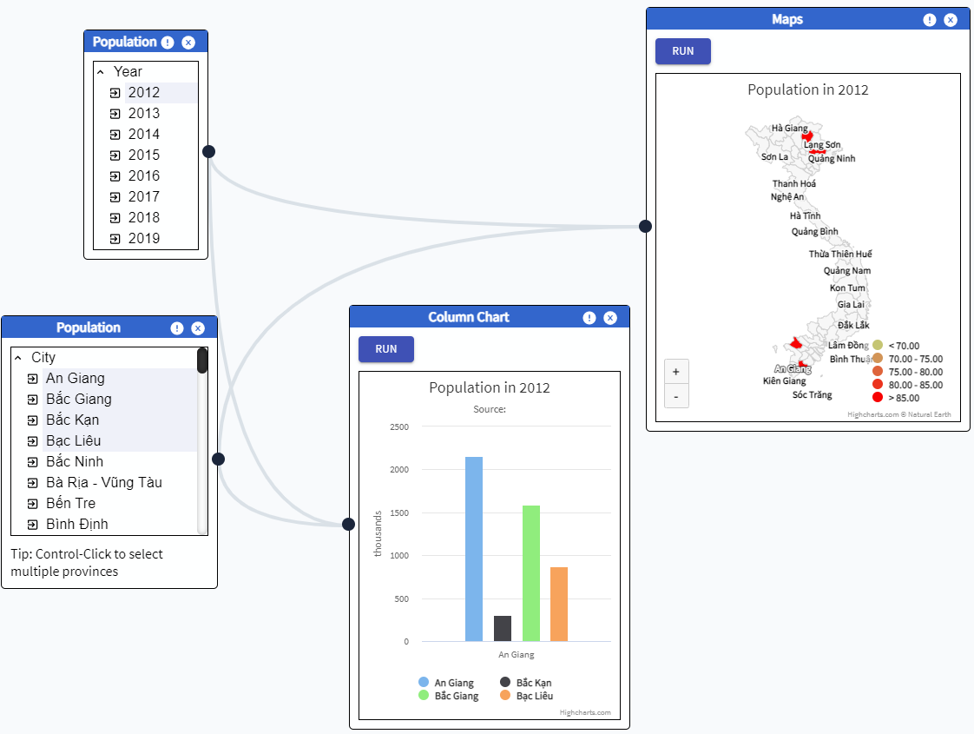

| **Cities In Year** | | | | |
| --- | --- | --- | --- | --- |
| **No.** | **Field name** | **Type** | **Require** | **Target** |
| 1 | Maps | HighChart/Highmaps | Width: 350px;  colorAxis: min: 50, minColor: "#E6E7E8",  maxColor: "#005645", | Population of cities in year |
| 2 | Chart | Column | Width: 300px; | Population of cities in year |
| 3 | colorAxis |  | Min: 0  minColor: b"rgb(197, 197, 115)", maxColor: "rgb(247, 2, 2)",  colorRange:   * To 80 * From 80 to 100 * From 100 to 110 * From 110 to 120 * From 120 to 130 * From 130   Hover: color: #EEDD66 |  |
| 4 | Maps Title |  | Default: “”  Running: “Population in ${year}” | Population in year |

## 